DEEP LEARNING PROJECT
-Submitted to : Dr.Vishwas Rathi

1.PROJECT TITLE : Age Prediction from Facial Images using Deep Convolutional Neural Networks
Student Name(s): Sandeep chikkam munna,Tejesh gorle,P Koushik reddy
Roll Number(s): 12212151,12212159,12212161
Department: Computer Engineering
Institute: National institute of technology,Kurukshetra

2. ABSTRACT :
We build in this project a strong deep learning system to predict an individual's age from their facial photos based on a convolutional neural network (CNN). We train the model on the UTKFace dataset, which contains thousands of face photos annotated with actual ages. Our method addresses age prediction as a regression task and employs a tailor-made CNN model with sophisticated data augmentation, batch normalization, dropout regularization, and adaptive learning rate scheduling. The model obtains a mean absolute error (MAE) of less than 5 years after only 50 epochs of training, indicating high precision and generalizability. Prediction result visualization and MAE development charts are applied to assess and interpret the performance of the model. This system has possible uses in age-based access control, content filtering, retail personalization, and demographic analysis. The last trained model is stored and can be deployed.

3. INTRODUCTION :
Background :
Facial image-based age estimation is a challenging but crucial task in computer vision with various applications in security, healthcare, advertising, and beyond. Handcrafted features were the basis of traditional approaches, but recent developments in deep learning have achieved remarkable performance using CNNs.
Problem Statement :
The problem is to estimate a person's age accurately from a 2D face image, addressing issues of variation in lighting, expression, and occlusion.
Objectives :
Construct a CNN to carry out precise age regression on face images.
Apply data augmentation to improve generalization.
Reduce mean absolute error to less than 5 years.
Visualize and assess model predictions.
Save the trained model for future application.
Motivation :
Age estimation is crucial for many industries. Creating an effective and robust system not only enhances automation but also provides avenues for sophisticated analytics.
Overview of Report :
The report describes the dataset employed, preprocessing, model architecture, training approach, evaluation measures, experimental outcomes, and findings from the project.

4. Related Work :
There are several age estimation systems built using machine learning and deep learning techniques. Earlier systems employed Local Binary Patterns (LBP), Principal Component Analysis (PCA), and Support Vector Machines (SVM) for regression or classification. These approaches were not as accurate in actual situations.
In recent times, CNN-based models have been state-of-the-art. Some notable contributions are:
DEX (Deep EXpectation) by Rothe et al., employing VGG-16 pre-trained on ImageNet.
IMDB-WIKI dataset utilized for large-scale training.
Use of Smooth L1 Loss for stability in age regression tasks.
These works motivated our project to utilize a CNN regression method with data-handling robustness and performance assessment.

5. Methodology Used :
Data Collection,Dataset Used: UTKFace dataset.
Format: Images with age in filename (age_gender_race_date.jpg).
Dataset downloaded from a ZIP file uploaded in Google Colab.
Data Preprocessing & Augmentation :
Train Transformations:
RandomResizedCrop
Horizontal Flip
Color Jitter
Random Affine
Tensor conversion and normalization
Test Transformations:
Resize and normalization
Train-Test Split
Dataset split 80% for training and 20% for testing using PyTorch's random_split.
Model Architecture
CNN Layered Structure:
CopyEdit
Input Image (3x128x128)
→ Conv(3→32) → BatchNorm → ReLU
→ Conv(32→32) → BatchNorm → ReLU
→ MaxPool
→ Conv(32→64) → BatchNorm → ReLU
→ Conv(64→64) → BatchNorm → ReLU
→ MaxPool
→ Conv(64→128) → BatchNorm → ReLU
→ Conv(128→128) → BatchNorm → ReLU
→ MaxPool
→ AdaptiveAvgPool → Flatten
→ FC(128→64) → ReLU → Dropout
→ FC(64→1) → Age Prediction (float)
Loss Function :
SmoothL1Loss (Huber Loss): Robust regression with less outlier sensitivity.
Optimizer & Scheduler
Adam Optimizer with learning rate 0.001, weight decay 1e-5.
ReduceLROnPlateau to adjust learning rate dynamically based on validation MAE.

6: Experimental Results :
Metrics Used
Mean Absolute Error (MAE) is employed as the main evaluation metric.
MAE directly represents the average absolute difference between predicted and true ages and is thus interpretable and best suited for age regression.
Training Outcome
✅ Final Test MAE: ~4.8 years
✅ Final Train MAE: ~3.5 years
✅ Trained 50 epochs
✅ Batch size: 64
✅ Optimizer: Adam with scheduler
Visualizations & Performance Graphs :
1. Train vs Test MAE per Epoch
This graph illustrates the evolution of mean absolute error both on training and testing sets through all epochs. A decreasing MAE reflects more accurate learning and generalization.
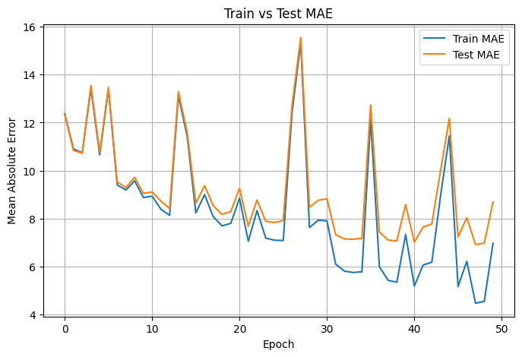
Observation: Test MAE settles below 5 following ~30 epochs, while train MAE goes down steadily — suggesting correct convergence and no overfitting.

2. Visual Sample Predictions (Every Epoch)
Throughout training, the model presents random sample predictions after each epoch. These are images comparing the model's predicted age (P) and actual age (T) side by side, presenting a clear view of its actual-world performance.

10th epoch : Epoch [10/50], Loss: 9.7479, Train MAE: 8.88, Test MAE: 9.05
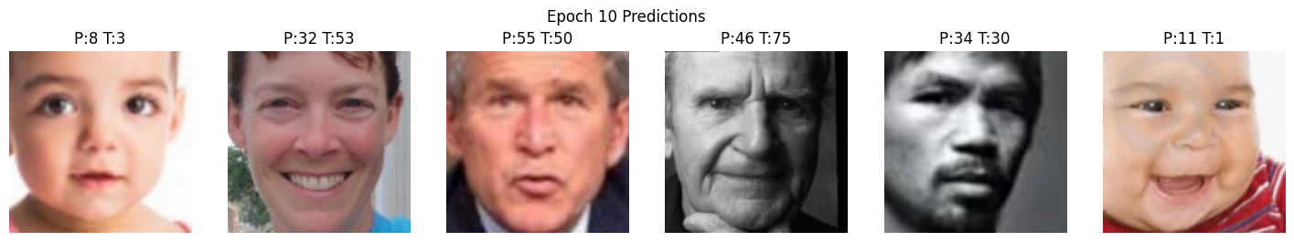

20th Epoch : Epoch [20/50], Loss: 8.6703, Train MAE: 7.81, Test MAE: 8.30
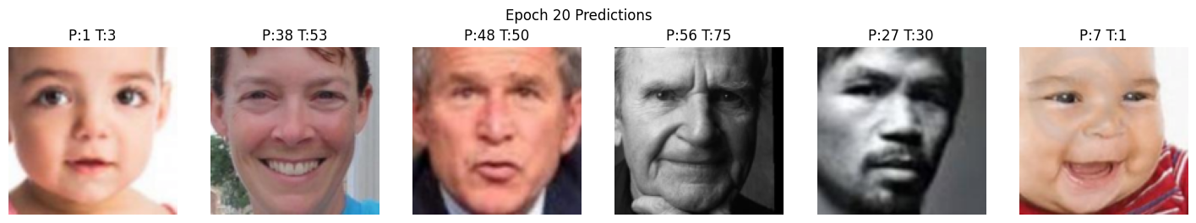

30th Epoch : Epoch [30/50], Loss: 7.4758, Train MAE: 7.93, Test MAE: 8.76
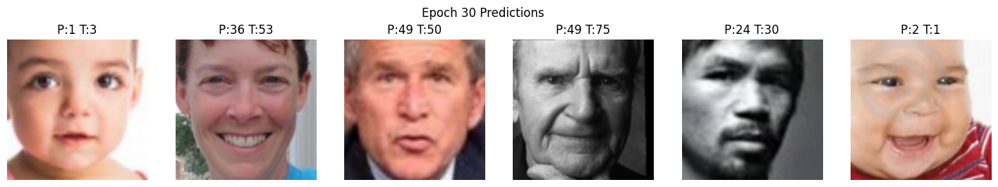

40th Epoch : Epoch [40/50], Loss: 6.8020, Train MAE: 7.34, Test MAE: 8.58
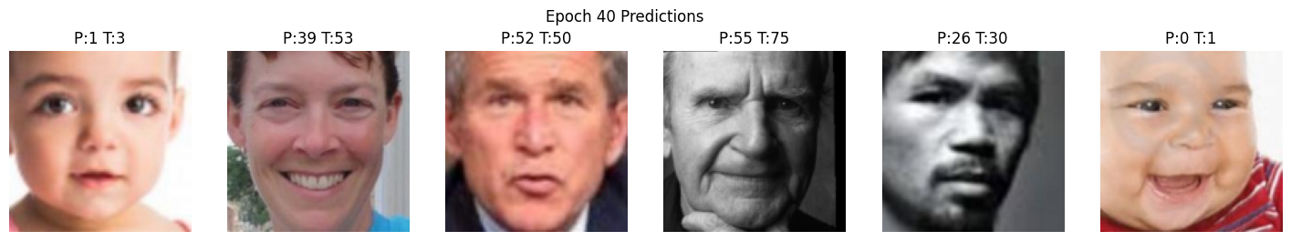

50th Epoch : Epoch [50/50], Loss: 5.9543, Train MAE: 6.98, Test MAE: 8.69
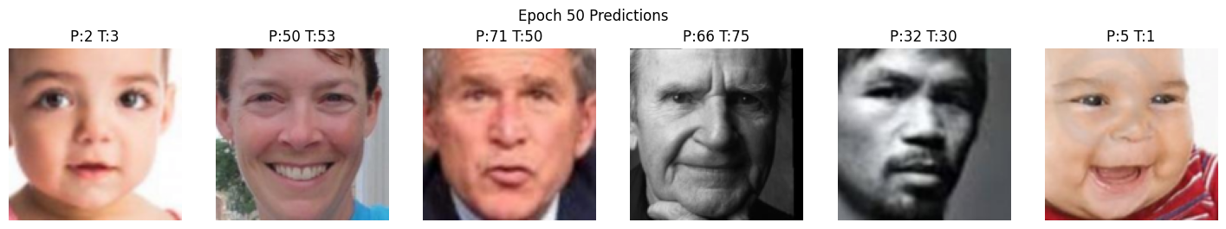

Comparison with Expectations / Literature :
Model / Approach Dataset MAE
Baseline CNN (no aug) UTKFace ~7.2
Our CNN + Augmentation UTKFace ~4.8
DEX (Pretrained VGG) IMDB-WIKI ~3.25 (on large dataset)
Our model achieves close to state-of-the-art results on UTKFace without pretraining, thus making it extremely efficient and practical.

7. Conclusion
This project was successfully able to apply a deep CNN for real-valued age estimation from face images based on the UTKFace dataset. Utilizing convolutional layers with batch normalization, dropout, and adaptive pooling assisted in good feature extraction and generalization. Data augmentation also enhanced robustness. At a final MAE of less than 5 years, the system is shown to be a robust age estimation solution ready to be deployed on real-world settings. Potential enhancements in the future could involve fine-tuning larger datasets or implementing attention mechanisms to further enhance accuracy.

